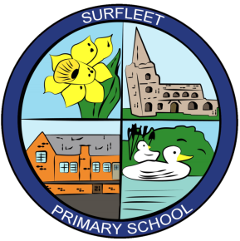

SURFLEET PRIMARY SCHOOL
1:1 Teaching Assistants
20 - 32.5 hours per week (various positions)
Grade G3.6 - £18,562 pa (Pro Rata)
We are looking to appoint a number of 1:1 Teaching Assistants to start as soon as possible, term time only, to join our small, friendly and hard-working staff team.
Relevant qualifications necessary.
Experience of working with children with a range of additional needs desirable.

The closing date for applications is noon on Friday 23rd September 2022 – interview date – Wednesday 28th September 2022.

Visits to the school are welcomed and should be booked in advance by contacting the e-mail below or school phone number.
Interviews will take place at the school observing all Government and PHE guidelines.
For more information or an application pack, please
e-mail: admin@su.keystonemat.org

Alternatively, all application documents are available on the school website under the Vacancy tab.

We are committed to safeguarding and all employees are subject to an enhanced DBS disclosure.

