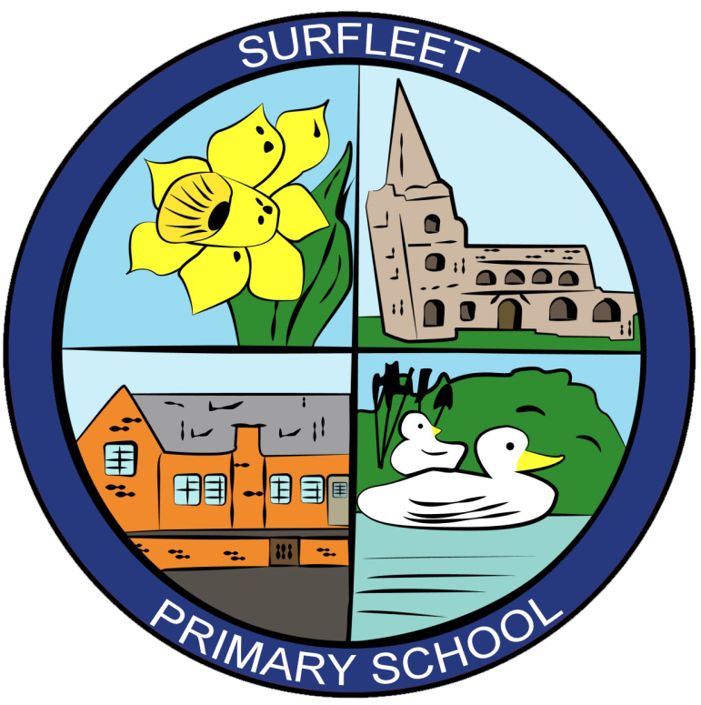

HOMEWORK POLICY

Review Date: September 2024

Introduction

At our school we recognise the vital role parents and carers play in the education of their children. We strongly believe in the value of home-school partnership, of which our homework policy is an important element.

Aims

Through this policy we aim to:
• Improve the quality of the learning experience offered to pupils and to extend it beyond the classroom environment.
• To use homework as a tool to help continue to raise standards of attainment.
• Provide opportunities for parents/carers, children and the school to work together in partnership in relation to pupil’s learning.
• Encourage pupils and their parents/carers to share and enjoy learning experiences.
• Reinforce work covered in class by providing further opportunities for individual learning.
• To practise or consolidate basic skills and knowledge, especially in Mathematics and English
• Encourage pupils to develop the responsibility, confidence and self-discipline needed to study independently.
• To prepare Year 6 pupils for the transfer to secondary school.
• Ensure that parents/carers are clear about what their child is expected to do.
• Ensure consistency of approach throughout the school.

The nature of homework

The nature of homework will change as pupils get older. For pupils in Reception and Key Stage 1, developing a partnership with parents and carers, and involving them actively in children's learning is a key objective. All year groups follow a weekly schedule for homework; this will be written in your child’s Learning Journal. Homework will take the form of short activities of different kinds – reading together, learning spellings and number facts -provide a very important opportunity for young pupils to talk about what they are learning to an adult, and to practise key skills in a supportive environment. As pupils get older, homework provides an opportunity for them to develop the skills of independent learning, which they will need to continue lifelong learning and this should increasingly become its main purpose. It is important that pupils should gradually get into the habit of regularly devoting periods of time, which may not be long, to study on their own. By the time pupils reach Class 3, their homework programme will cover a wide range of tasks and curriculum content, with a regular weekly schedule. This approach will benefit their learning and also ensure that, in relation to homework as much as to other aspects, the Year 6 transition to Year 7/Secondary school is as smooth as possible.

Homework will be differentiated to take account of individual pupils needs and may
include:

Home Reading
The importance of reading at home cannot be over-emphasised and we hope that pupils will read for pleasure in their own time. Pupils will be provided with a suitable school reading book, which can be taken home to read with a parent/carer or other adult. A Learning Journal is provided for parents to sign and make comments when they have listened to or read to their child. Pupils in Upper Key Stage Two will be expected to take responsibility for their own reading books as necessary.

Spellings
Spellings will be given to each child to learn using the Look, Say, Cover, Write and Check method. Spellings will be differentiated by pupil ability; others may be key words from topics.

Mathematics
In Key Stage 1, pupils will be given Mathematics homework to consolidate their understanding of number facts including times table recall. In Key Stage Two homework will be provided for pupils to consolidate or revise particular mathematical skills which will have been covered in recent lessons. Parents and carers will be asked to sign off homework in their learning diaries to indicate that it has been completed.

English
In Key Stage two pupils will be given English homework in addition to spellings and reading. This may include consolidation of vocabulary, punctuation and grammar skills, development
of reading comprehension and small writing tasks related to current English work.

Topic Work
All pupils will receive holiday homework at the end of each term, linked to the topic they will be studying when they return after the break. Pupils will be given the opportunity to research topics they are studying in class as they move through Key Stage 2. In upper Key Stage 2 pupils may be asked to produce projects related to their topic over a longer period of time.

Other homework activities may include:
• Handwriting Practice
• Preparing questions
• Puzzles/games
• Learning songs or scripts for plays
• Investigations

Time to be spent on homework
Recommended time for homework is as follows, if you find your child’s homework is taking much longer, please speak to your class teacher.

Years 1 and 2 – 30 minutes per week
Years 3 and 4 – 45 minutes per week
Years 5 and 6 – 1 hour week

Implementation

Foundation
In Reception, the pupils take home reading books on a regular basis to read with parents/carers to reinforce the Key Words from the scheme presently being covered. Word cards and “sounds” may also be sent home.

Year One and Year Two
• Pupils take home a reading book, which is changed regularly. Pupils are encouraged to read little and often, (i.e. up to 10 minutes) a minimum of three times per week. A Learning Journal is also sent home to record any successes, concerns etc.
• A weekly spelling list, appropriate to ability, is also sent home to learn, using the ‘look, cover, write, check’ method.
• During the year, pupils will be asked to think about certain aspects of their Topic work, and may be asked to bring objects/photographs/information from home to support their learning in school.
• Pupils are also encouraged to practice number bonds and to learn the appropriate times
tables (e.g. 1, 2, 5 and 10).

Year Three and Year Four
• The Learning Journal will have expectations of daily reading.
• There will be graded spellings each week with an assessment during the week.
• There will be new mental maths targets set for the children at the beginning of each term.
• Homework will be set each week, which may consist of English, Maths or Topic based activities to consolidate classroom based learning.

Year Five and Year Six
In upper Key Stage Two, pupils will be set English or Mathematics homework weekly. The days are set and recorded in their learning journal. Children will also receive weekly spelling lists and times tables to learn. In addition to this pupils may be set science or topic homework. These tasks may reinforce new concepts, consolidate skills or require information research beyond the classroom.

Communication to Parents and Carers
Parents/carers will be informed of ways in which they can support and assist their children at
home in the ‘Welcome’ pack given to all parents of Reception pupils. There will be curriculum meetings as part of the induction process to suggest ways that parents can support Reading.
When pupils move up a year group, homework expectations will be explained in the class.

It is expected that all children will complete their homework. We encourage them to do this at home to support parental involvement, but if children choose not to do it at home, then they will be asked to complete it during a break or lunch time at school.

