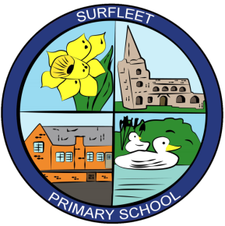
Executive Headteacher: Mr A Raistrick
Head of School: Mr R Chipperfield

Surfleet Primary School
Station Road, Surfleet, Spalding, Lincolnshire. PE11 4DB
Tel: 01775 680373
Email: admin@surfleet.lincs.sch.uk
Website: www.surfleet.lincs.sch.uk

Reception
Welcome to your child’s first year at Surfleet, where they are able to develop and progress from their own individual starting point through The Early Years Foundation Stage Curriculum. We encourage and support children to engage and learn through structured and free play with planned purposeful activities that provide opportunities for learning both indoors and outdoors.
We create a stimulating and enriching learning environment for all children’s differing learning styles and levels, ensuring all children are supported and challenged in their everyday learning experiences and opportunities. We want children to be natural inquisitors who explore, question and take chances in their learning enabling them to be independent learners and be able to apply their knowledge and skills in their own real life environments.
The Early Years Foundation Stage Curriculum is made up of 7 areas which can be seen throughout our classroom. These areas are:-
- Personal, Social and Emotional Development
- Communication and Language
- Physical Development
- Literacy
- Mathematics
- Understanding the World
- Expressive Arts and Design
Within The Early Years Foundation Stage Curriculum there are also Characteristics of Effective Learning which we support through provision within our learning environment. These are:-
- Playing and Exploring
- Active Learning
- Creating and Thinking Critically

