April 2019

Dear Applicant

Thank you for requesting application details for the post of class teacher.

Please complete the application form and a covering letter, returning it to school for the closing date of Friday 10 May 2019. In your letter of application, please include copies of your feedback from your last three lesson observations. The letter should also include your skills, relevant experience, your educational values and your reasons for applying for the position at Surfleet Primary School.

If you have any questions regarding any of the above or you require further information, please do not hesitate to contact me. Visits are welcomed. Please contact us to arrange. More information regarding the school can be found on our website www.surfleet.lincs.sch.uk.

I look forward to hearing from you.

Yours sincerely

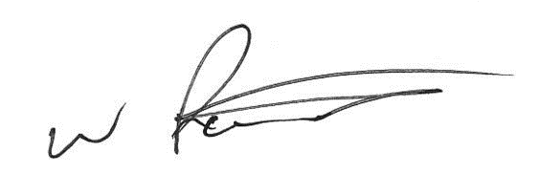

Mr A Raistrick

Executive Headteacher

